Docker Calculator Pull
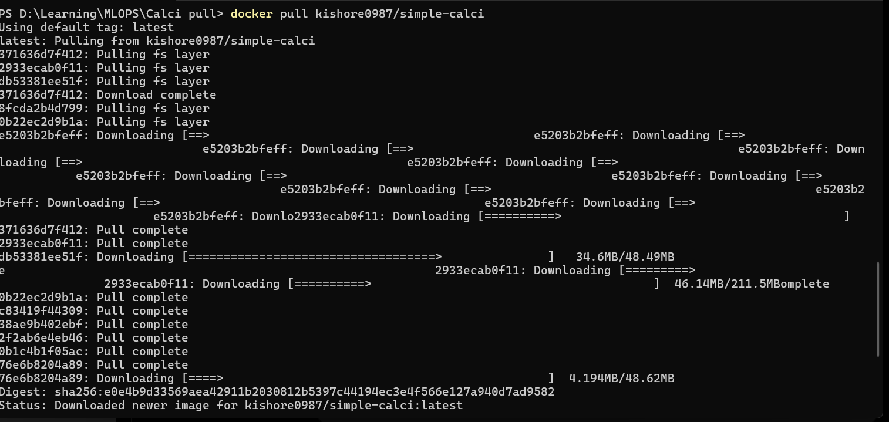
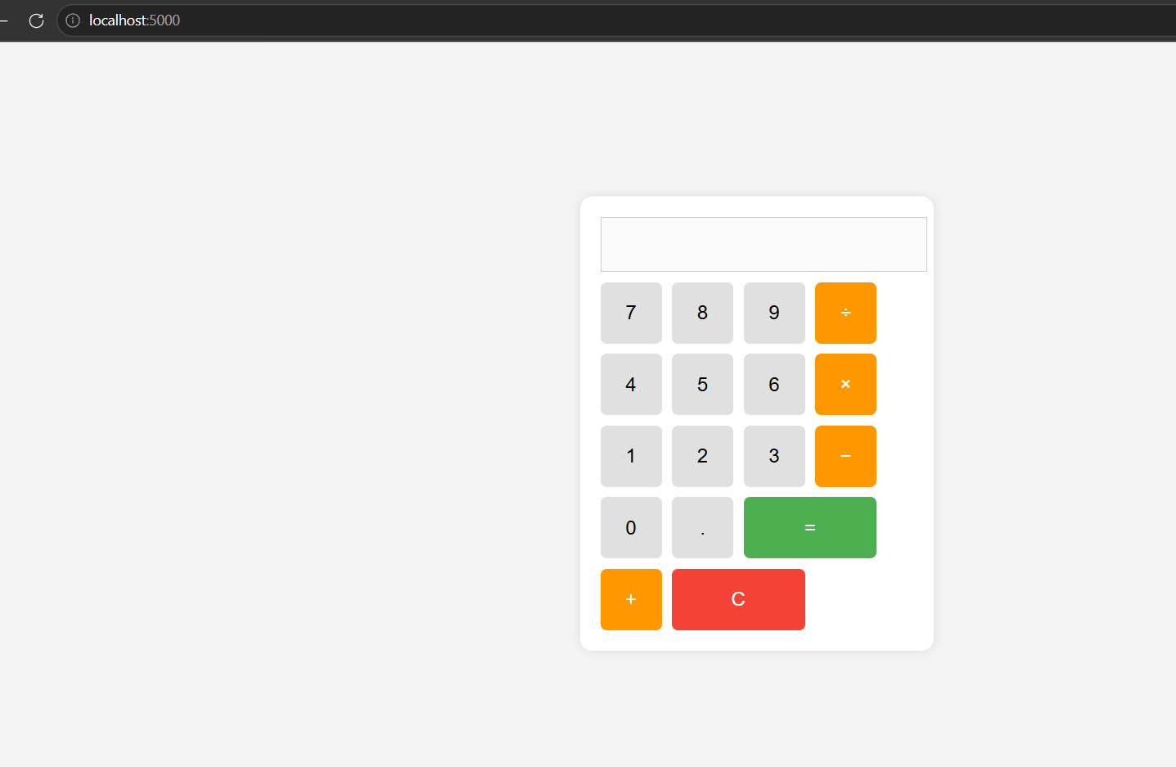

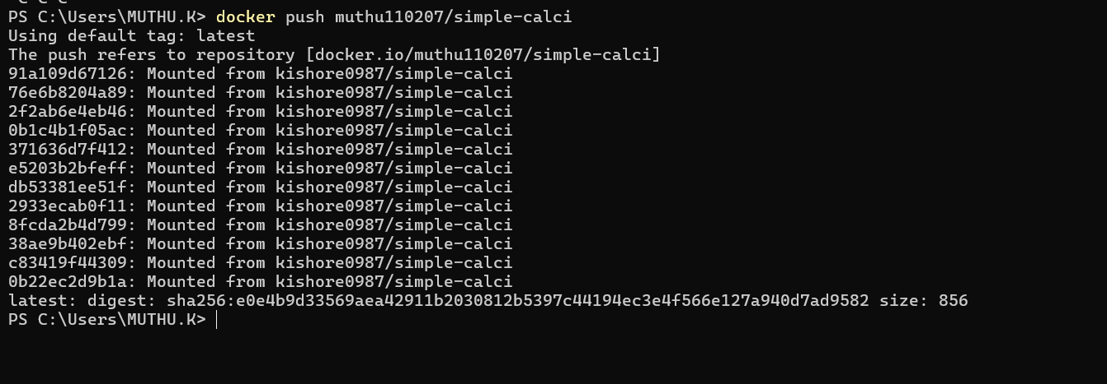
docker Repo Link : https://hub.docker.com/repository/docker/muthu110207/simple-calci/general

